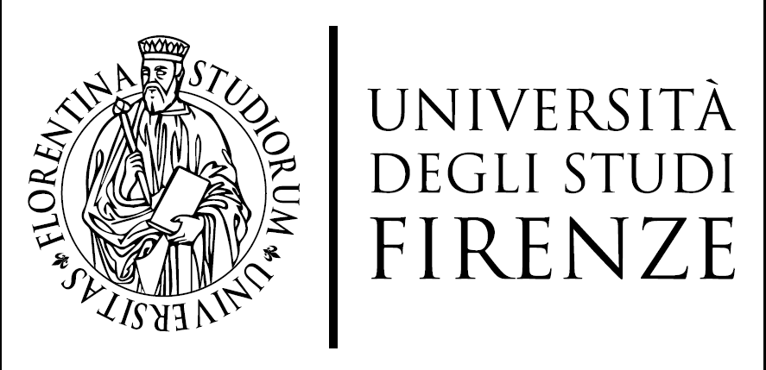
SCUOLA DI STUDI UMANISTICI E DELLA FORMAZIONE

Nome of company | Kultkom – Kerstin Wiehe
Website | www.kultkom.de
Company address | Crellestraße 22, D – 10827 Berlin
Sector of the internship | Cultural management
Internship Description | Conception and maintenance of social media and web, establishment and maintenance of contact database, research and acquisition of funding, contacting ensembles, orchestras, opera houses, worldwide, budgeting, project management, partner search and maintenance, concept development in the field of contemporary music, music theatre, visual arts and interdisciplinary works (involved in various projects).  Knowledge, skills and competences to be acquired (expected Learning Outcomes): Evaluate artistic quality, grant writing (copy), conceptualise and design marketing materials (print, social media, photos, etc.), Strategic development of artistic content presentation, project management skills; overview of programs, funding systems, residencies, etc. - international - and the new music scene and its networks in other artistic fields
Duration of the internship | 6 month
Period of the internship | Free - Ideally adapted to the semester times
Working hours | 35
Candidate requirements | Independent work, curiosity and openness also for working hours outside office hours during productions, possibly travelling, Good and appreciative communication (verbal and written) is absolutely necessary: Furthermore: little shyness about getting into contact with strangers. Good understanding of language and a desire to formulate. A good understanding of numbers and more complex contexts would also be desirable.
Graduate or postgraduate | Both is possible
Language requirements | German, English
Mentor/Contact person for traineeship  (please fill name, position and email) | Kerstin Wiehe, CEO, wiehe@kultkom.de

Note

